入住指南|云谷茶境欢迎您

Welcome to Yungu Tea Retreat --Check in Guide

飞机

Aeroplane

出发点—合肥新桥机场

Departure point--Hefei Xinqiao Airport

1. 合肥新桥机场 7号门 （大巴）----潜山城市候机楼----出租车----痘姆乡求知村云谷茶境民宿
Gate 7, Xinqiao Airport, Hefei (bus)----Qianshan City Terminal----Taxi----Yungu Tea Retreat in Qiuzhi Village, Doumu Township.
2.合肥新桥机场 机场大巴（3号线）----合肥南站(高铁)----潜山站（高铁）----出租车----痘姆乡求知村云谷茶境民宿
Hefei Xinqiao Airport Bus (Line 3) ---- Hefei South Station (High speed Railway) ----Qianshan Station (High speed Railway) ---- Taxi ----Yungu Tea Retreat in Qiuzhi Village, Doumu Township.

3.合肥新桥机场 机场大巴（1号线）----大西门地铁站----步行到地铁2号线安徽农业大学站----三孝口站----（换乘）地铁五号线----合肥南站（高铁）----潜山站（高铁）----出租车----痘姆乡求知村云谷茶境民宿
Hefei Xinqiao Airport Bus (Line 1) ---- Daximen Subway Station ----Walk to Line 2 Anhui Agricultural University Station ----Sanxiaokou Station ----(Transfer)----Line 5-----Hefei South Station (High speed Railway)----Qianshan Station (High speed Railway)---- Taxi ---- Yungu Tea Retreat in Qiuzhi Village, Doumu Township.

4.合肥新桥机场 出租车----合肥南站（高铁）----潜山站(高铁)---出租车----痘姆乡求知村云谷茶境民宿
Hefei Xinqiao Airport Taxi ---- Hefei South Station (High speed Railway) ---- Qianshan Station (High speed Railway) ---- Taxi ---- Yungu Tea Retreat in Qiuzhi Village, Doumu Township.

出发点—安庆天柱山机场

Departure point --Anqing Tianzhushan Airport
1.1安庆天柱山机场 出租车----安庆站（高铁）----潜山站（高铁）----出租车----痘姆乡求知村云谷茶境民宿
A Anqing Tianzhushan Airport Taxi ---- Anqing Station (High speed Railway) ---- Qianshan Station (High speed Railway) ---- Taxi ---- Yungu Tea Retreat in Qiuzhi Village, Doumu Township.

2． 安庆天柱山机场 公交（101路）----安庆站（高铁）----潜山站（高铁）----出租车----痘姆乡求知村云谷茶境民宿
Anqing Tianzhushan Airport Bus (Route 101) ---- Anqing Station (High speed Railway) ---- Qianshan Station (High speed Railway) --- Taxi --- Yungu Tea Retreat in Qiuzhi Village, Doumu Township.

高铁

High speed Railway

出发点—各地高铁站

Departure point -- High speed railway

·各地高铁站--潜山站（高铁）--出租车--痘姆乡求知村云谷茶境民宿
High speed railway stations in various regions----Qianshan Station (high-speed railway) ----Taxi --- Yungu Tea Retreat in Qiuzhi Village, Doumu Township.
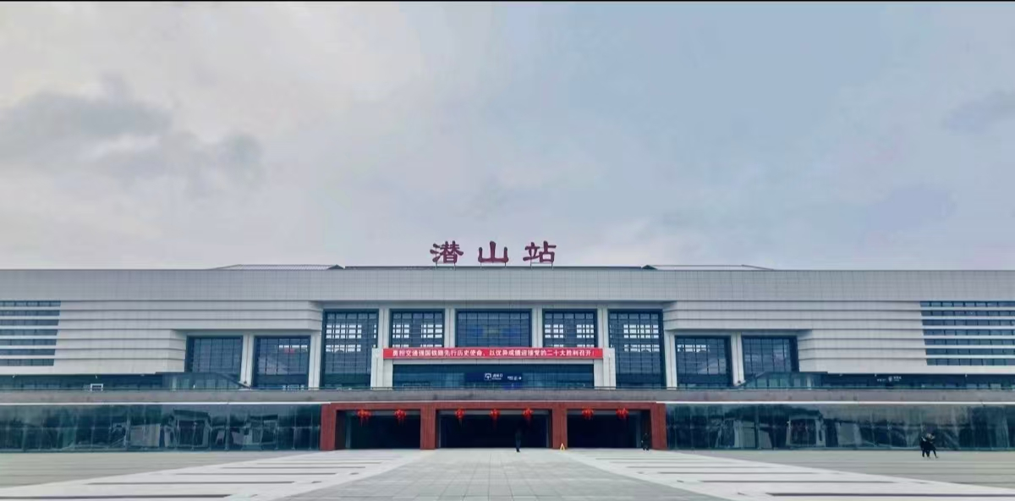
必经车站 must pass station
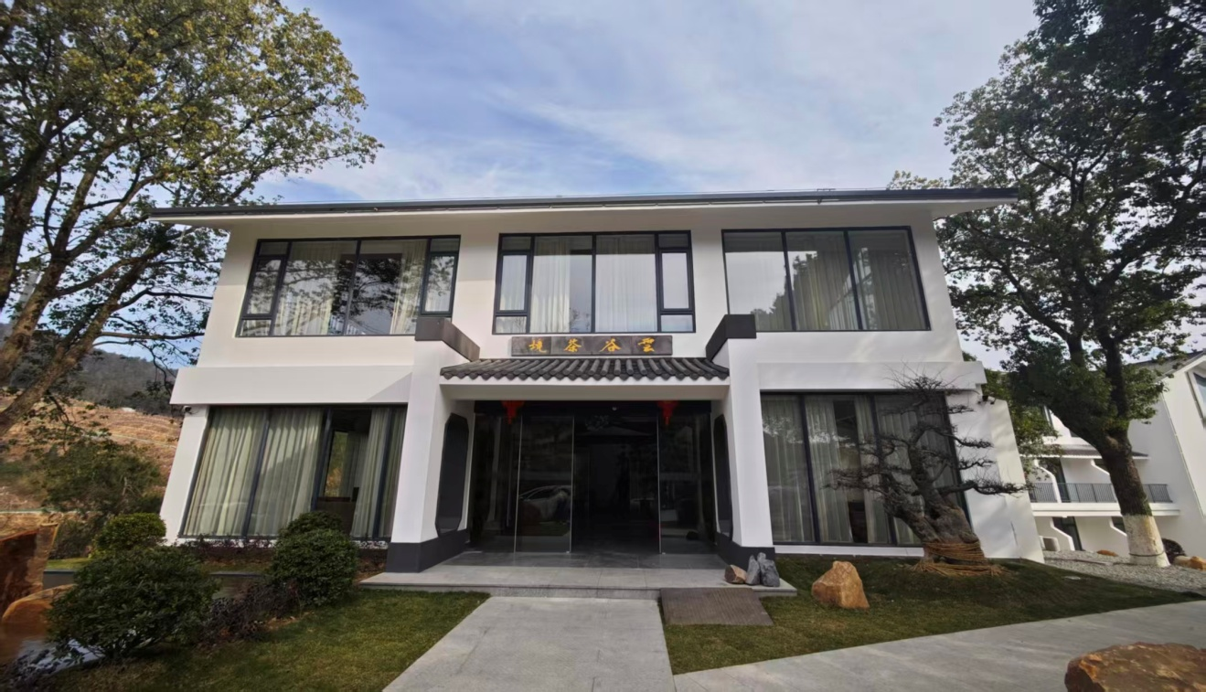目的地 destination

云谷茶境欢迎您！

Welcome to Yunge Tea Retreat

如有需要，可拨打客服电话：18855669796

If necessary,you can call customer service:18855669796

